Basic Linux Commands

- ls
- allows us to see what files and directories exist within the file system.
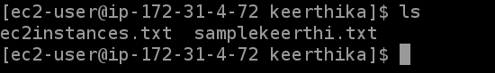

Ls -a
to show all the hidden files and folders
ls -l
The -l option use print out a list of files with detailed descriptions.
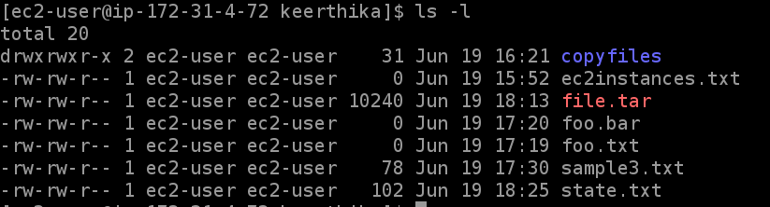
- Pwd
The pwd command in Linux is short for present working directory.
It shows the path of the current working directory

- Cd
- To go to a directory or navigate through the directories
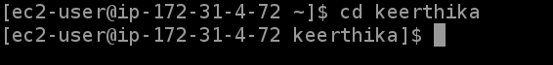

- Cp
- To copy from current directory to another directory
- Touch
- used to create, change and modify timestamps of a file without opening
- Mkdir
- it is used to Create a directory

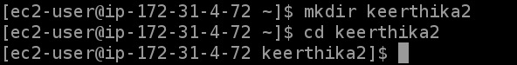

- Rmdir
this command is used to remove a directory

- Rm
this command is used to Remove the files and directories .
Warning that it delete all the content of the files as well
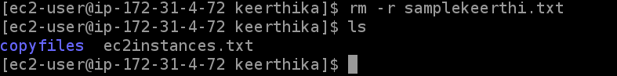
9. Date
Shows the current date and time

- Ps
Shows the current running process

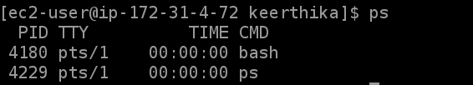

11. cat
The cat command in Linux is used to read the contents of one or more files and display their contents inside the terminal
5 Networking Commands

- Ping
The ping command is used to ensure that a computer can communicate to a specified device over the network. The pings command sends Internet Control Message Protocol(ICMP) Echo Request messages in the form of packets to the destination computer and waits in order to get the response back. Once the packets are received by the destined computer, it starts sending the packets back. This command keeps executing until its interrupted.
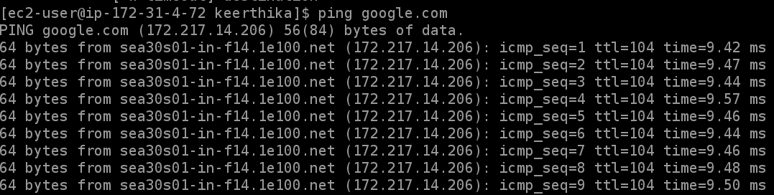

2. ifconfig : ifconfig is used to initialize an interface, configure it with an IP address, and enable or disable it. It is also used to display the route and the network interface.
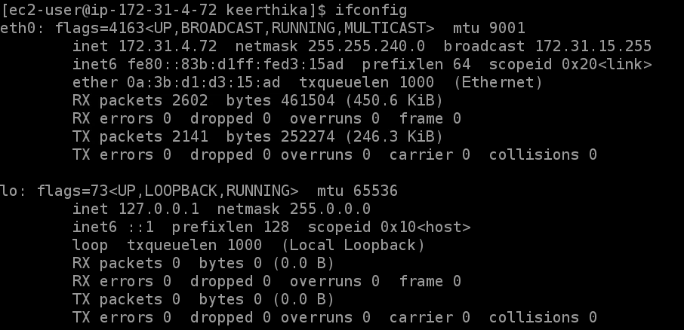
This picture shows the IP address of 3 networks, Ethernet, local network, and WLAN.
To get details of specific interface

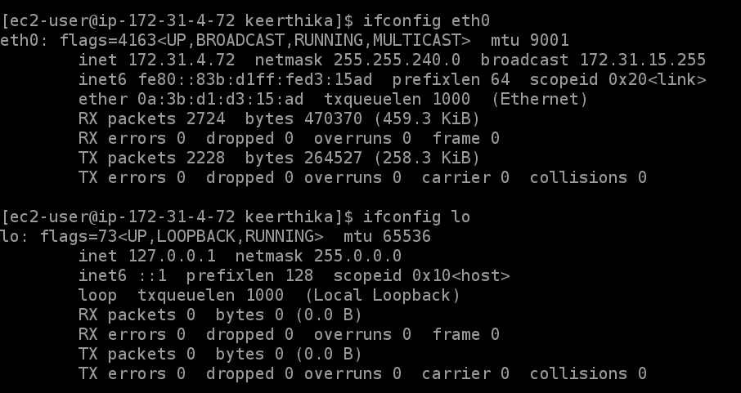
1. To enable specific interface : ifup eth0
2. To disable specific interface : ifdown eth0

3. ip
This is the latest and updated version of ifconfig command.

Syntax:
- ip a
- ip addr
This command gives the details of all networks like ifconfig.

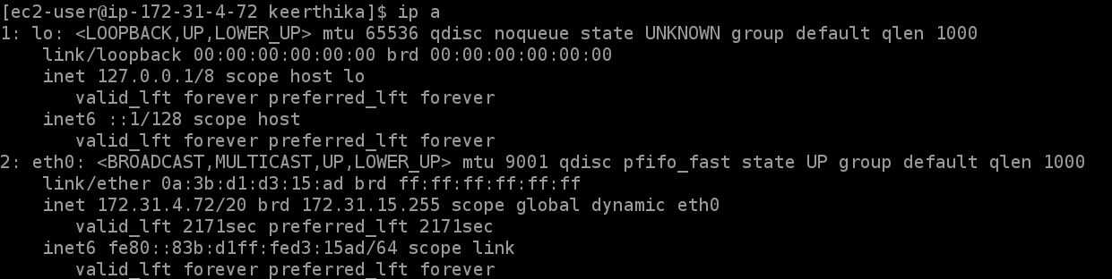

4. traceroute
Linux traceroute is one of the most useful commands in networking. It is used to troubleshoot the network. It detects the delay and determines the pathway to your target
It provides the names and identifies every device on the path.
It follows the route to the destination
It determines where the network latency comes from and reports it.

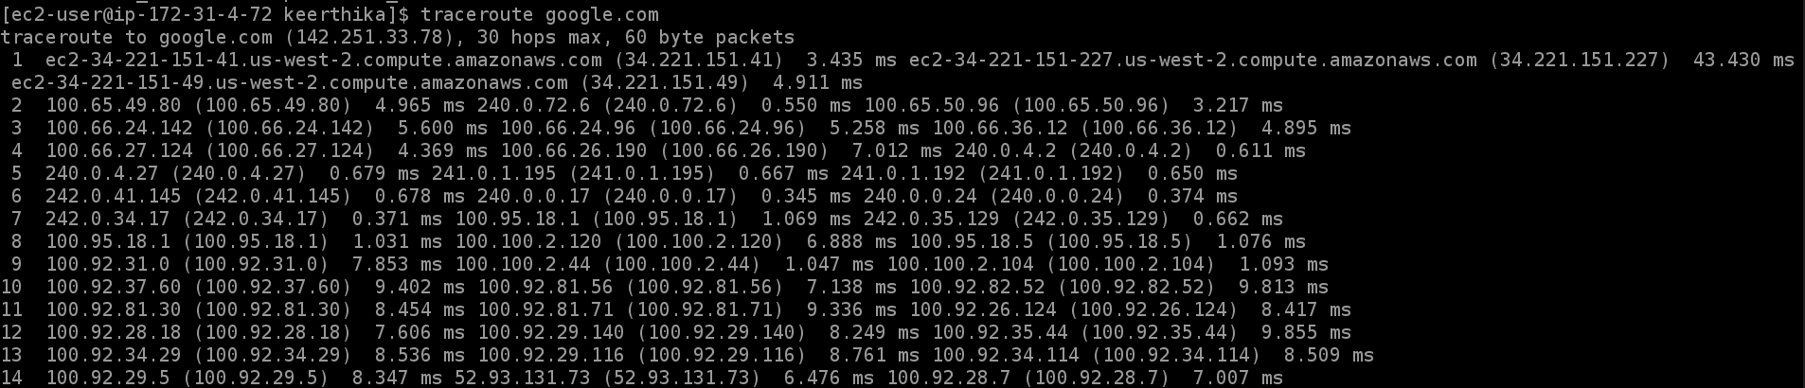
5. netstat
Linux netstat command refers to the network statistics.
It provides statistical figures about different interfaces which include open sockets, routing tables, and connection information.
1) To display the programs
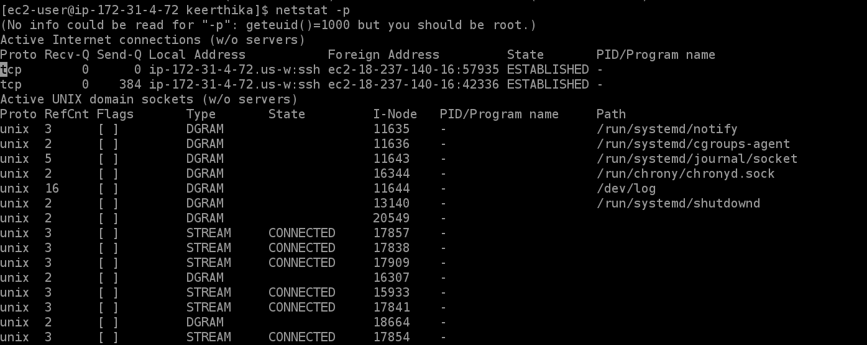
2) To get the details of the ports

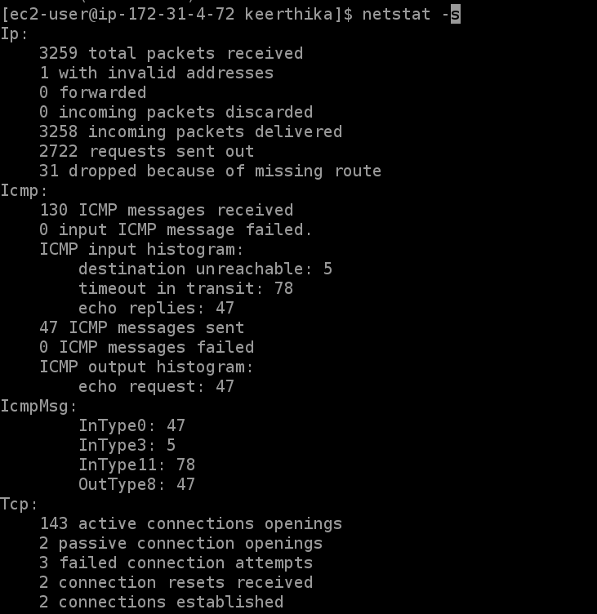
netstat -a : Show both listening and non-listening sockets
netstat -at : To list all tcp ports.

netstat -au : To list all udp ports.

netstat -l : To list only the listening ports.

netstat -lt : To list only the listening tcp ports.

5 Process related Commands

1. top : top command displays a list of processes that are running in real-time along with their memory and CPU usage

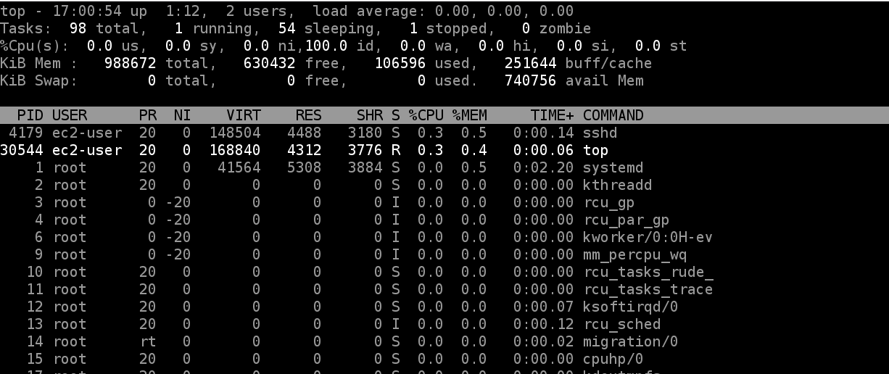

2. PS
This command stands for ‘Process Status’. It is similar to the “Task Manager” that pop-ups in a Windows Machine when we use Cntrl+Alt+Del. This command is similar to ‘top’ command but the information displayed is different.
To check all the processes running under a user, use the command –
ps ux

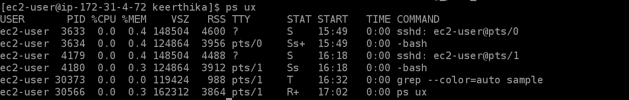
ps pid

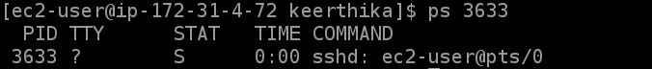

3. KILL
This command terminates running processes on a Linux machine.
4. DF
This utility reports the free disk space(Hard Disk) on all the file systems.

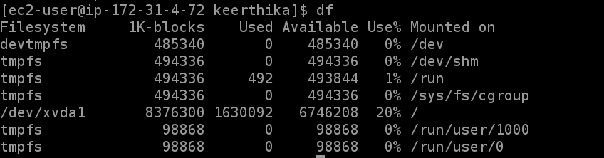

df -h
If you want the above information in a readable format, then use the command
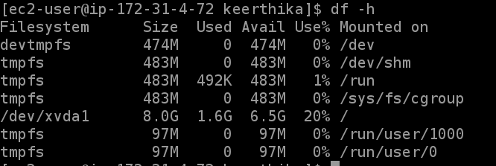
5. Free
This command shows the free and used memory (RAM) on the Linux system.
You can use the arguments
free -m to display output in MB
free -g to display output in GB
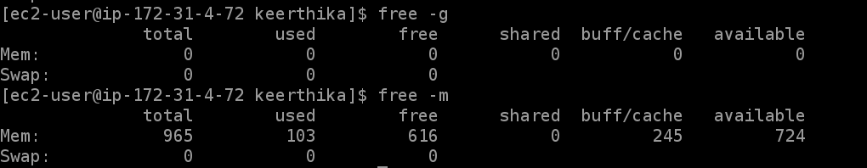
5 Searching and replacing commands

1. sed
Replacing or substituting string : Sed command is mostly used to replace the text in a file

2. grep
The grep filter searches a file for a particular pattern of characters, and displays all lines that contain that pattern.

The -i option enables to search for a string case insensitively in the given file. It matches the words like “UNIX”, “Unix”, “unix”.

Displaying the count of number of matches : We can find the number of lines that matches the given string/pattern

3. AWK : It searches one or more files to see if they contain lines that matches with the specified patterns and then perform the associated actions

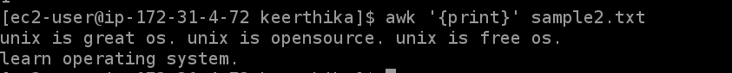
Print the lines which match the given pattern.

4. find
The find command in UNIX is a command line utility for walking a file hierarchy. It can be used to find files and directories and perform subsequent operations on them.

5. find and delete

When this command is entered, a prompt will come for confirmation, if you want to delete sample.txt or not. if you enter ‘Y/y’ it will delete the file

find empty files
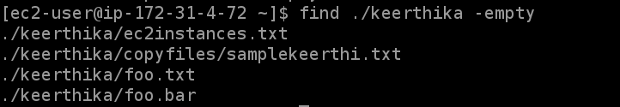
5 Volume related commands

1. fdisk -l : It is used to view all available partition in the system.

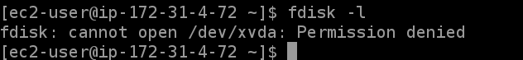
2. sudo (Super User DO) command in Linux is generally used as a prefix of some command that only superuser are allowed to run.

-V:The -V (version) option causes sudo to print the version number and exit.
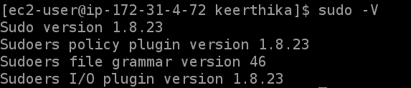

-l:The -l (list) option will print out the commands allowed (and forbidden) the user on the current host.

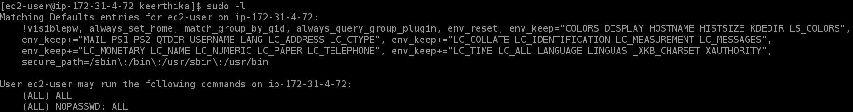
3. df
The df command is used to display information related to file systems about total space and available space.

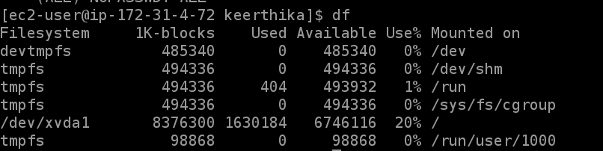
4. df -h
-h, –human-readable : print sizes in power of 1024

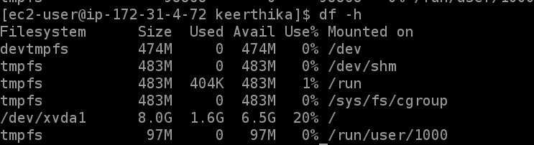
df -T

-T, –print-type : print file system type

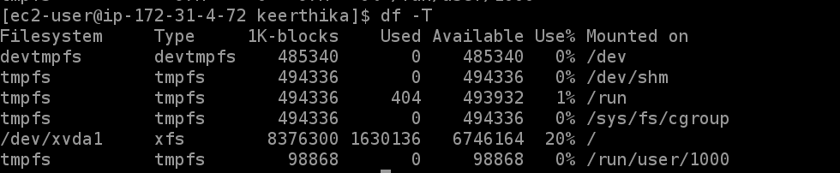

Mandatory commands

1. grep
The grep filter searches a file for a particular pattern of characters, and displays all lines that contain that pattern.

The -i option enables to search for a string case insensitively in the given file. It matches the words like “UNIX”, “Unix”, “unix”.

Displaying the count of number of matches : We can find the number of lines that matches the given string/pattern

egrep :

The egrep command belongs to the family of the grep command which is used for pattern searching in Linux. If you have used the grep command, egrep works the same as grep -E (grep Extended regex’) does. Egrep scans a specific file, line to line, and prints the line(s) that contain the search string/regular expression

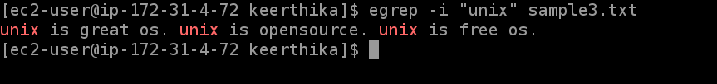

2. find
The find command in UNIX is a command line utility for walking a file hierarchy. It can be used to find files and directories and perform subsequent operations on them.

3. du
It is used to check the information of disk usage of files and directories on a system.
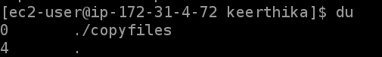

4. scp
scp (secure copy) command in Linux system is used to copy file(s) between servers in a secure way.

scp [option] [user_name@source_host:path/to/source/file] [user_name@target_host:target/path]

5. tar
The Linux ‘tar’ stands for tape archive, is used to create Archive and extract the Archive files.
1. Creating an uncompressed tar Archive using option -cvf : This command creates a tar file called file.tar which is the Archive of all .c files in current directory.

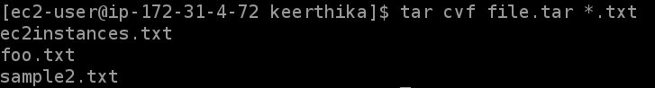
2. Extracting files from Archive using option -xvf : This command extracts files from Archives

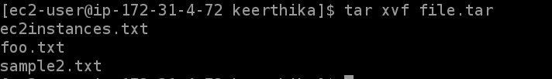
3. gzip compression on the tar Archive, using option -z
$ tar cvzf file.tar.gz *.c

4. Extracting a gzip tar Archive *.tar.gz using option -xvzf
$ tar xvzf file.tar.gz

5. Creating compressed tar archive file in Linux using option -j : This command compresses and creates archive file less than the size of the gzip. Both compress and decompress takes more time then gzip.
$ tar cvfj file.tar.tbz example.cpp

6. df
The df command is used to display information related to file systems about total space and available space.

7. cp

- To copy from current directory to another directory

8. mv : mv command is used to move files, although it can also be used to rename files.

1. -i (Interactive): Like in cp, the -i option makes the command ask the user for confirmation before moving a file that would overwrite an existing file, you have to press y for confirm moving,
2. -f (Force): mv prompts for confirmation overwriting the destination file if a file is write-protected.
3. -b(backup): With this option, it is easier to take a backup of an existing file that will be overwritten as a result of the mv command

9. tail
The tail command, as the name implies, print the last N number of data of the given input. By default it prints the last 10 lines of the specified files.

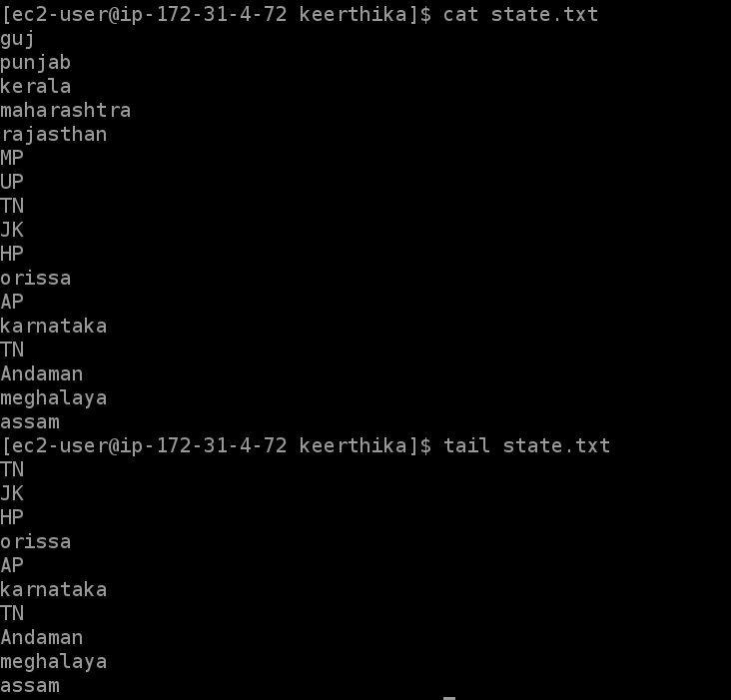
-n num: Prints the last ‘num’ lines instead of last 10 lines

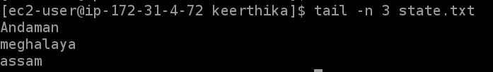
-c num: Prints the last ‘num’ bytes from the file specified ,
-q: It is used if more than 1 file is given. Because of this command, data from each file is not precedes by its file name.

